**Imprisoned dissident women in Cuba denounce systematic sexual abuse and torture by prison staff**

May 10, 2023 by [Carlos Eire](https://babalublog.com/author/dr-carlos-eire/)

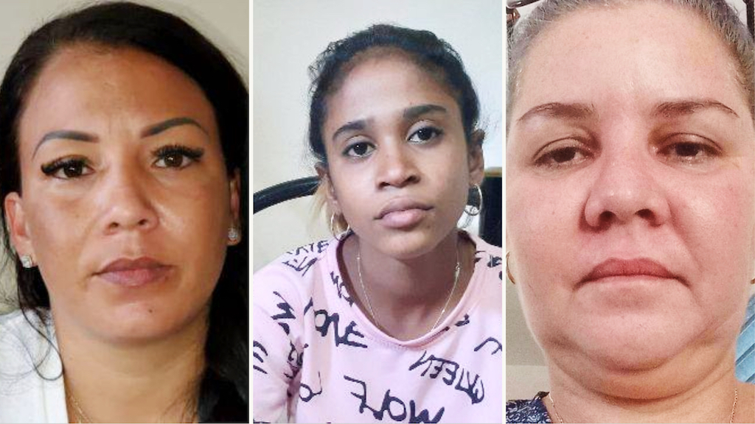

Rape victims Yeilis Pérez Cruz, Gabriela Zequeira Hernández y Diasnurka Salcedo Verdecia.

*Two men who called themselves Manguera (“The Hose”) and Mandarria (The Sledgehammer) were taken by prison authorities to Yeilis Pérez Cruz’s cell at “100 and Aldabó street” Prison, on the third day of being held there, and raped her.*

*“They did it several times and I am sure that many of the girls arrested for the protests of July 11 (2021) who passed through there (that Prison) also suffered the same thing, because that was one of the first attacks they committed against us,” she explained in an interview with DIARIO DE CUBA. .*

*She also denounced that, both in “100 and Aldabó” and in “Villa Marista” (another detention center), the violations against the prisoners are constant and inhumane.*

*“Those people have no scruples, they have no feelings, they are devils, they are led by a diabolic dictatorship and they themselves have become devils. If I remember correctly, the name of the one who brought these two characters to my cell is Abel, who had the rank of captain.”*

*Abel, is the same name that a young woman detained during the July 11 protests in Havana, Gabriela Zequeira Hernández, mentioned in her testimony.*

*“They were on top of me for more than three hours in the most disgusting way, I don’t know if they were officers or inmates. Pérez Cruz denounced as soon as she arrived in the US in statements to Martí News.*

*The activist assures this newspaper that the order to attack her in this way came “directly” from the criminal investigator who was in charge of her case, named Freyre. “He wanted to play human, but he’s a devil; while I was in jail he showed me videos of my daughter walking down the street and he told me that, the same thing that was happening to me (the sexual raping), it could happen to my daughter, and that they couldn’t do anything to stop it.”. . .*

*. . . On condition of anonymity, a 32-year-old woman, now on probation, agreed to tell this newspaper what she experienced in the “100 and Aldabó” prison in May 2021. She explained that the first thing that happened to her when she arrived at the prison was that although she had her menstrual period, they did not want to give her compresses for the bleeding. “I was like this for three days, bleeding and bleeding without being able to put anything on. To make matters worse, there was no water, I don’t even want to remember that.”*

*The abuse against this young woman did not end there: “Five days later an officer came to look for me to take me to another cell, they left me alone there for about half an hour until an officer opened the door and they put two men in who raped me for at least two hours in a row.****They told me that was what I got for being so rebellious.”***

*There is also the case of the Cuban human rights activist Diasniurka Salcedo Verdecia, who denounced at the end of 2020 that two agents of the Political Police sexually abused her during an arrest.*

*“I was mistreated in the worst way that a human being can be mistreated. When I say mistreated, I mean it with bigger words. (…) All women know what I mean when I was mistreated by two men: sexually and in the most brutal way”, he denounced in a harsh way, through hes Facebook wall.*